* **MC – One of Australia’s finest Cultural Ambassadors** - **Sean Choolburra**

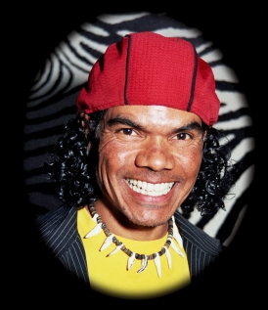

* **JOB SHOP**

Woorabinda CDEP, Job Services Australia (JSA) providers and Centrelink staff will be on hand to help jobseekers access the Jobs Board and to assist with applications and resumes.

* Performances by local musicians and dancers
* Facepainting for the kids
* Community Showcase Displays
* **Koora the Kangaroo**
* Special guest appearance by Sydney Rabbitohs NRL player and CQ sporting legend **Rhys Wesser**



* Lucky prize draws for jobseekers including **Johnathan Thurston** signed State of Origin polo shirt & player shorts courtesy of the **Toyota North Queensland Cowboys**
* Food & drinks available
* Lots of giveaways

If you have any queries about the Woorabinda Jobs Expo, please contact **Janis Frost** **Manager - Community Services, Woorabinda Aboriginal Shire Council on (07) 49 259 802 or 0438 126 941 or** [**govtrain@woorabinda.qld.gov.au**](mailto:govtrain@woorabinda.qld.gov.au)

Our 2011 Jobs Expo is just over a week away and it’s great to welcome back many of last year’s exhibitors:

* Advanced Personnel Management
* Anglo Coal
* Australian Agricultural College
* Capricorn Training Company
* Career Employment Australia - IYMP
* Central Highlands Regional Council
* Central Queensland Indigenous Development (CQID)
* Central Queensland Institute of TAFE
* Central Queensland University
* Construction Skills Queensland
* CQID
* DEEDI
* DEEWR
* Department of Communities
* Department of Community Safety
* Department of Environment & Resource Management
* GAGAL
* Juwarki
* QBuild
* QR National
* Queensland Police
* Queensland Fire & Rescue
* Queensland Health
* Rio Tinto Alcan Yarwun
* Rockhampton ICC
* Skills DMC
* Wesfarmers Curragh Mine

We are also pleased to welcome a number of new exhibitors:

* Australian Bureau of Statistics
* Back on Track
* Beyond Billabong
* Blue Care
* Bunnings
* Compass Group
* Community Solutions/NDCO
* CQ NRL Bid
* Defence Force Recruiting
* Gladstone Ports Corporation
* Indigenous Business Australia (IBA)
* JBS Australia
* John Holland Group
* Mercy Health & Aged Care CQ
* Peabody Energy Australia
* Racing Queensland
* Rio Tinto Coal Kestrel Mine
* Skilling Solutions Queensland
* Thiess

**Wednesday 12 October 2011**

**Issue 5, OCTOBER 2011**