Woorabinda
IEP Community Information Day
Tuesday, 14th February 2012
12pm
at the Red Shed.
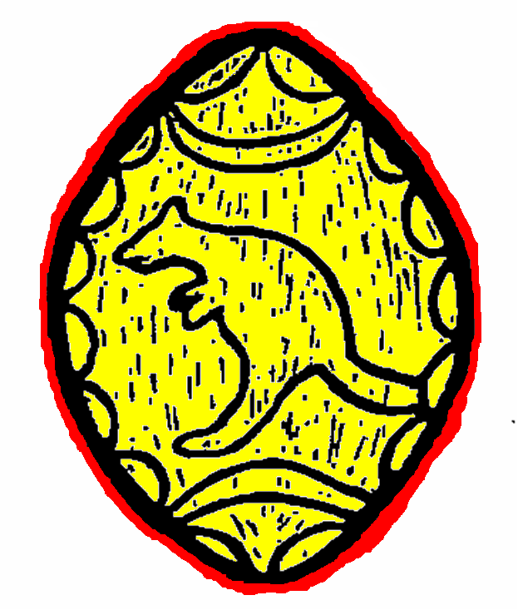BBQ Supplied.

