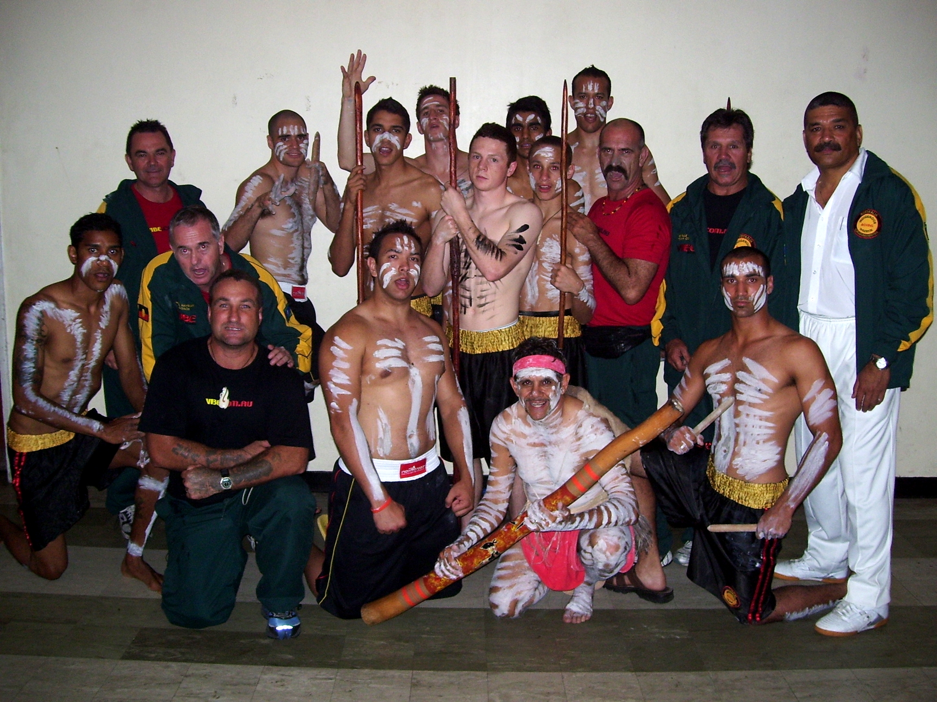
6
5
7
4
3
15
2
17
8
16
1
9
10
11
12
13
14
2007 Australian Indigenous Warrior Team

What were they doing then, Where are they now ?

- Timacoy Williams - was working in construction, he is now studying a Double degree at UQ.
2. Luke Jackson, working with a roofer, He is now in London as
The Captain of the Australian Olympic Boxing Team.

3. Adrian Andrews was studying a certificate in law to join the
police, when visiting the Australian high Commissioner on
Tour of Fiji, we met with the federal attach’e – Adrian is now
in Federal police in Canberra.

4. Jason Williams was on a disability pension, now working a s
Scaffolder in construction

5. Neal Hayman was working for protective services, now a
Police Liaison for Dalby and surrounding districts – has not
had a Juvenile in court for 3 months !!!

6. Sam Leone – was a sheet metal worker, he has completed a
Cert 1V in Community Welfare , is now working as a “family
and youth coordinator at Kurbingui Youth Development.

7. Don Abnett- was the National Talent Identification Coach,
He is the Current Australian Olympic Boxing Coach
( currently in London )

8. Fred Capes - was unemployed and now working as a car
detailer, He has since competed a Cert 1V in Fitness Training.

9. Joel Hutcheson – was working as a trades assistant and is
now a qualified Roofer.

10. Nathan Carrol- was in a Boxing scholarship at the AIS,
is now a Professional Boxer – winning the QLD
middle weight title to date.

11. Cameron Hammond - was unemployed , won a scholarship
to the AIS and is currently in London as the
69kg – Australian Olympic Champion

12. Stephen Pitt - worked as a level 3 Administration Officer, after
Completing a Diploma in Government, He is now a manager in
the office of the Attorney General

13. Syl Johns – AO4 indigenous support officer, did a diploma in
Business, took on the position as Indigenous Training Manager,
is currently writing “Warrior Programs”.

14. Neville Munn – was working in Demolition, did a diploma in
Community Welfare – Currently working For Queensland Rail.

15. Ceru Whippy- Referee, was working as an installer
for an Australian company, is now a small business Owner.

16. Tyler Johns – was working at a car wash in Deagon,
is now a fully Qualified Systems Electrician

17. Michael Connolly, was working from Home in his own
Business, now has a shop front in Redcliffe

