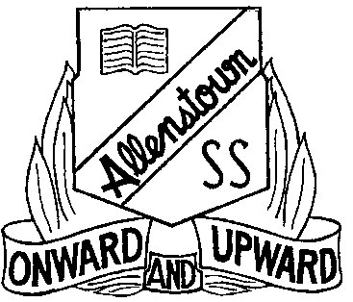

The Allenstown Annex and Family Planning Queensland are excited to announce:
Protection Thru Play - Playgroup
Family Planning Queensland, Rockhampton, in partnership with Allenstown State School, will provide parents, carers and their children FREE access to a play group at The Allenstown Annex.
The playgroups project is designed to support families through fun and family-friendly activities.

Playgroup will Begin on Friday February 8th 2013
When: Fridays during School Term 9-11am
Where: The Allenstown Annex -H Block – Building beside the pool
Cost: Free – including tea, coffee and morning tea

To register your interest or for further inquiries contact: Melanie McAllum at Allenstown State School 49300111 or email mmcal27@eq.edu.au

This Communities for Children Project is funded by the Australian Government under the Family Support Program.
Family Planning Queensland, Rockhampton on 49 213 655.

