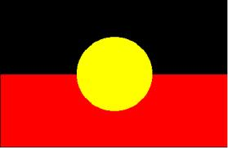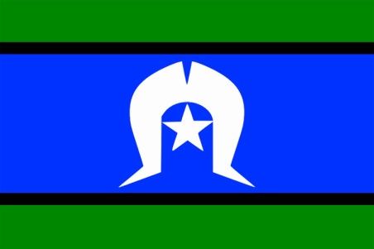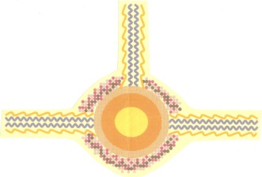



**Gladstone**

**One Day Only**

**Venue: Nhulundu Health Service**

**(Cnr Hixon and Manning Sts)**

**Date: Wednesday 5th June**

**Time: 4pm**

**Free BBQ & Info sessions**

**Skills Survey**

**Language Centre**

**Aboriginal Arts**

**Cultural Heritage**

**All Murris Welcome!**

**Come see us and talk about opportunities in Jobs, Arts, Training, Language**

For more information contact Gordon 0409696219