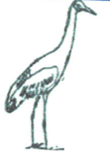

Joskeleigh Community Association



For further details, contact:

Doris Leo – 49344 854

Tricia Brown – 49344 753

ABN: 55 086 678 253

Please join us for a fun afternoon with family and friends

**Adults: $10.00 (Includes Stew, Damper, Desserts & tea or coffee)**

**Kids(0-8 yrs): $5 (Includes Stew, Damper and Dessert)**

**2nd plate:**

* **Stew: $3.00**
* **Dessert—$2.00**
* **Tea/Coffee - $1.00**
* **Softdrink—$1.00**

**Trivia $2.00 per player (table of 6 players)**

**2013 - Commemoration of 150th Anniversary of the First Arrival of South Sea Islanders transported to Queensland**

**Trivia**

**Homemade Stew & Damper Lunch**

**Saturday 6th July**

**10.30am**