Child Protection
Community Legal Education for Queensland

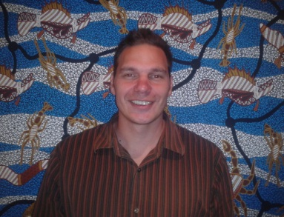
The gross over-representation of Aboriginal and Torres Strait Islander children in care is well known. Community Legal Education in this area is a vital tool to assist in addressing this appalling state of affairs. Mr William (Will) Hayward (pictured) will be delivering a series of local workshops on this subject (at no cost) – and stakeholders, community representatives and parents alike are encouraged to attend and participate.

A key aim of our workshops is to resource community members and key supporting stakeholders to ensure an increased ability to appropriately interact with the Department of Communities – Child Safety Services. BUT – we also want to hear from you: how can we best help?

Our Workshops will include a consideration of:

* The Queensland Child Protection Act 1999 and Regulations

* Stages of child protection - Intake, Investigation and Assessment and Ongoing intervention

* Family Group Meetings/Case plan review meeting

* Aboriginal and Torres Strait Islander specific child protection legislation

* Reviews, appeals and complaints processes

* Queensland child protection model
Location: | Date: | Bookings required: YES | Capacity
The HACC Hall  Woorabinda | 9th of October | 1 day session from 9:00am until 4.30pm | 40 plus persons

* Benefits of legal representation and collaborative partnerships

Feedback from the recent Community Education Forum held in Brisbane highlights how positive and responsive participants viewed the forum. “ATSILS invites debate while distilling complex legal terminology into easy to access information for families and their supporters. I urge practitioners to engage with ATSILS at a significant time in Aboriginal & Torres Strait Islander legal access history. Dynamic, culturally informed and compelling.”

