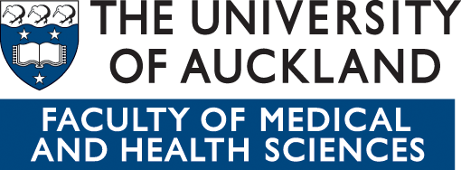

Scholarships to attend the 2014 Service User Academia Symposium

This first Service User Academia Symposium was organised by the University of Auckland in 2011 for the purposes of bringing together those who worked in academia and service users to explore and reflect on the challenges in creating and maintaining meaningful involvement of service users in mental health and addiction research and teaching. Such was the enthusiasm and interest generated that it was decided this should be an annual event.

In 2012 the University of Otago and CQUniversity joined with the University of Auckland to become official co-hosts of the event. With the theme of University Challenged the 2nd symposium was held as another one day event in Auckland and in 2013 the 3rd symposium with the theme of Making Change Happen was held as a two-day event in Melbourne.

The 4th Service User Academia Symposium - Creating Connections – Building Bridges Together -
will be held 1st and 2nd December 2014 in Wellington, New Zealand and the co-hosts are pleased to announce the availability of 2 scholarships to support service users to attend.

ELIGIBILITY
Applicants must:
- be a New Zealand or Australian citizen or a New Zealand or Australian permanent resident
- identify as a service user/survivor/consumer
- be currently involved (in some capacity) in mental health research and/or teaching
- have an interest in developing yourself as a service user academic.

VALUE
Each scholarship has a value of $1500 to contribute to the travel and accommodation expenses associated with attendance; and a free registration (valued at approximately $250).

APPLICATION AND SELECTION PROCESS
Applicants are asked to write about 750 words explaining how you fit the criteria and:
- what you anticipate getting out of the symposium
- how you intend contributing to the symposium
- how you will use the symposium to build service user academia capacity

All applications must be received by Dr Sarah Gordon no later than 20th April.

Recipients of the scholarships shall be selected by a panel comprising of representatives from the University of Otago (NZ), the University of Auckland (NZ), and CQUniversity (AUS).

For more information or to submit your application:
Dr Sarah Gordon
Department of Psychological Medicine
University of Otago Wellington
Telephone Number: 0064 7 8235025
Email Address: sarah.e.gordon@otago.ac.nz

