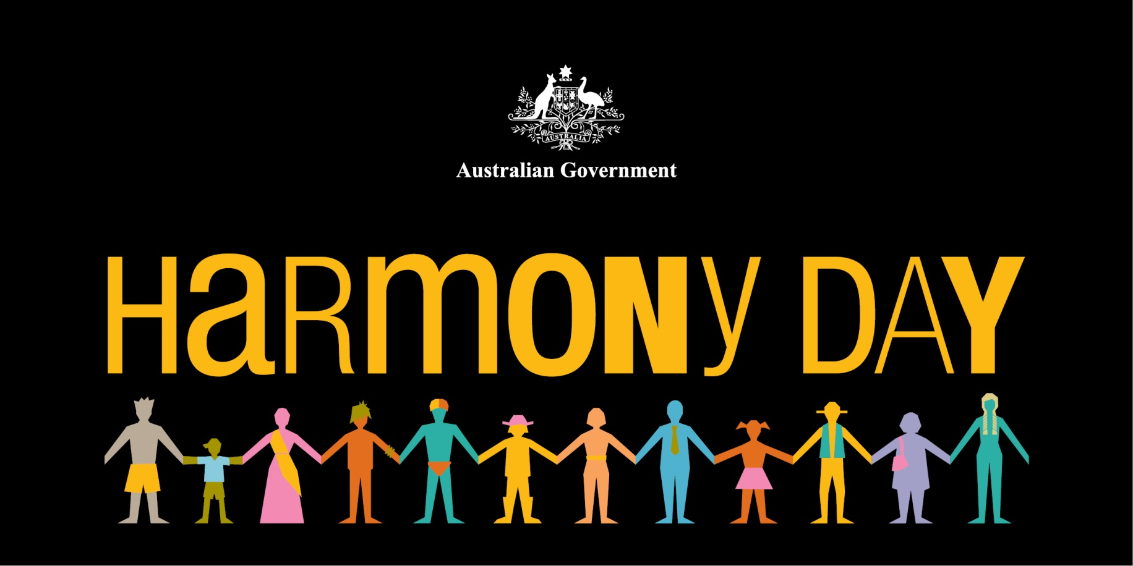

# You are all welcome to help us celebrate “Harmony Day”, Australia’s diversity. It is a day of cultural respect for everyone who calls Australia home – from the traditional owners of this land, to those who have come from many countries around the world. Let us learn and understand how all Australians from diverse backgrounds equally belong to this nation and make it a better place.

# This day will involve a meeting point at PCYC, Nth Rockhampton, and walking together, across the old bridge for a sausage sizzle. Please note 8am is the departure time, no later.

# 

Date: Friday 21st March 2014

Meeting Venue: PCYC, 16 Bridge Street, Nth R’ton

Time: 8am sharp

Arrive at the CDB Boardwalk at 8.15am for sausage sizzle

R.S.V.P - Annette Dudley 4930 4600 or 0407 685 420