Please find below details of the QWCA Cottages for rent or lease to community groups, organisations or individuals.

Please support this valuable community organisation retain its valuable assets by leasing or renting their premises which will otherwise be sold.

Beach Cottage
- 10-Bedrooms each with their own ensuites furnished with their own built in ward robes and drawers.
- Provision for Television sets.
- One bedroom has a double bed, all others with single beds.
- Large kitchen well set up with table and chairs suitable for wheelchairs recipients, refrigerator, small bench-top 2 hotplate stove, microwave and electric frypans etc and kitchen utensils
- Large lounge with Television
- Laundry with washing machine, trolley and tubs with clothes lines, Utility and ironing rooms

Shell Cottage has 12 Bedrooms and detailed with the same as above.
- Also included in the whole complex are a commercial Kitchen, and commercial Laundry
- Administration offices and recreation rooms and 1 Bedroom flat.
Reef Cottage, Sunset Lodge
16 Hewitt Street
Emu Park Queensland, Australia 4710

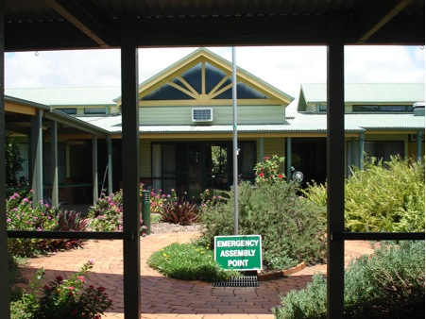
Situated 40km east of Rockhampton in the quiet village of Emu Park.
Beach and shops close by. Bus stop at door.
Wheelchair accessible holiday cottage
8 bedrooms with single beds, each with own bathroom.
Fully furnished with TV, ariconditioning, kitchen cutlery and crockery provided.
Laundry faciliaites available
Reasonable tarrifs

- Please contact the QWCA on 4939 2914 or on mobiles; 0431 577 550/ 0407 034 268 to view the premises or if you have any question.

Donate...
Queensland Country Women's Association | Privacy Policy

