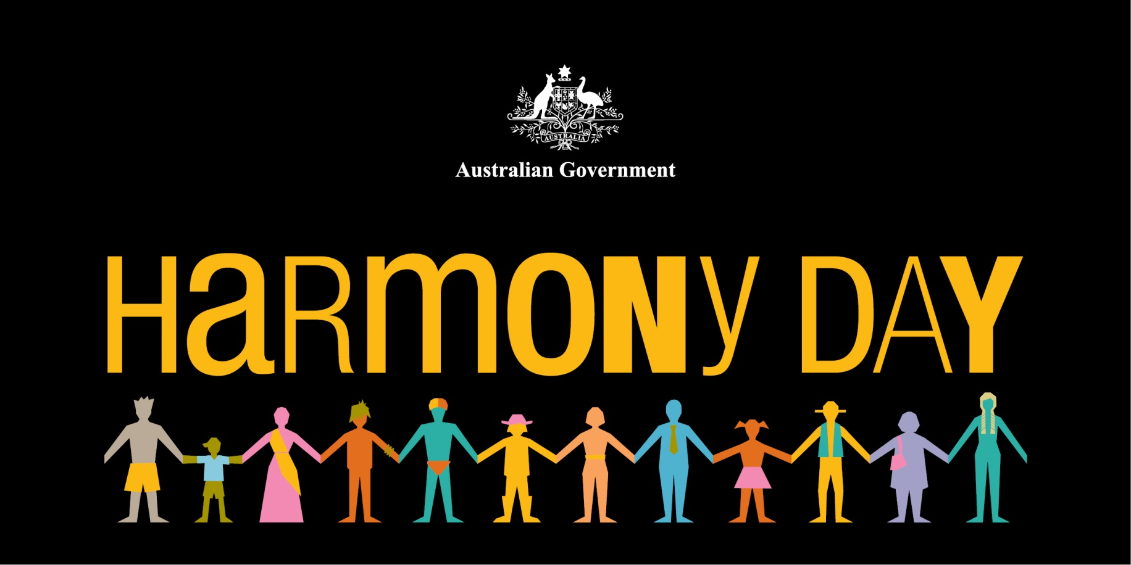

# Let’s Celebrate

The Harmony Working Group and the Capricorn Coast Multicultural Group supported by Central Queensland Multicultural Association extends an invitation to our entire community member from all culture and spiritual beliefs to a BBQ at the Beach. Let us celebrate our difference and support each other in building an Australian community that is open, caring and confident.

**Harmony Day Event**

Where: Anderson park- Ross Creek, Yeppoon

When: Saturday 22nd March

Time: 11am- 1pm

Please bring your own chair for your comfort and if it rains on the day, the venue will be held at Yeppoon- CWA Hall near Yeppoon Police Station. For more information please contact Joy Davison lee on 4925 0124