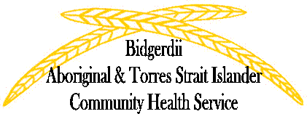

Bidgerdii Aboriginal & Torres Strait Islander Community Health Service
Social & Emotional Well Being Program invites you

To the 2nd

“Reconnecting the Inner Passion Workshop.”

Presenters: Annette Dudley & Leslie Purcell

Location: Dreamtime Cultural Centre, Nola James Room
Date: Friday 11th April 2014
Time: 10:30am-3:30pm
Placements have been limited to 80 people

This workshop is open to all Aboriginal, Torres Strait Islander and South Sea Islander Community Sector Workers free of charge.

Please RSVP by Thursday 4th of April for catering purposes. Placements will be limited to 80 people. For further information please email Annette Dudley rc-sewb-3@bidgerdii.org or Leslie Purcell rc-sewb-2@bidgerdii.org or call 49 304600.

“Reconnecting the Inner Passion Workshop.” Agenda
10:30am | Traditional Welcome  Introductions, overview, icebreaker.  Morning Tea  Group Photo
10:45am | Update since last Dreamtime Workshop
11:00am | Individual Journey documenting
11:30am | Group Discussion “Why I work in the Sector”
12:00pm | Lunch
1:00pm | Break up into Two Groups  Annette-1st Group, “Hearing our stories, Journal reflection”  Leslie- 2nd Group, “Why I work in the Sector”  Group activity until 2:45pm
1:45pm | Break for 15 mins
2:00pm | Feedback from Group activities
2:45pm | Afternoon Tea
3:00pm | Open safe discussion “Sector Matters”
3:30pm | Finish “Reflection”

