Tanku tumas

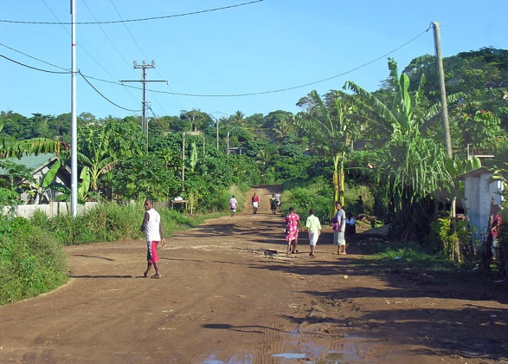
AUSTRALIA PIKININI CANECUTTERS

INFORMATION SESSION

05TH APRIL 2014 (SATURDAY

Pikininis & adults who made the trip to Vanuatu in December 2013 will share about their cultural experience& would like to say a big tanku tumas to you.
Come along & listen to how your grateful contribution assisted each of us & the communities / people in Vanuatu; come share over cake & a cuppa
We will be showing a PowerPoint presentation also; both pikininis & adults will speak about the day to day week-long journey that made a big impact for each of them so much so that we want other interested pikininis to share this cultural experience again.
Australia Pikinini Canecutters
Cheryl M –0417 966 759
Sharon Y – 0487 398 395 Joanne W –0408 164 207

2:00PM
49 HOWES ROAD FARNBOROUGH
YEPPOON

