Queensland Indigenous Youth Leadership Program

About the program
Applications for the 2014 Queensland Indigenous Youth Leadership Program are now open.
This six-day residential program is an exciting opportunity for young Aboriginal and Torres Strait Islander Queenslanders (18–25 years) to develop leadership skills and learn about our democratic processes.
It will be held in Brisbane from Saturday 21 June to Thursday 26 June 2014, with participants returning home on Friday 27 June. All travel including flights and transfers, meals and accommodation will be provided for participants.
If selected, you’ll have the opportunity to:
- participate in leadership and professional development workshops run by community leaders, facilitators and mentors
- take advantage of mentoring and networking opportunities with Elders and respected Indigenous community leaders, as well as Members of Parliament and senior government representatives
- experience the role of a member of parliament for a day with a mock legislative experience called the Eric Deeral Indigenous Youth Parliament ( http://www.parliament.qld.gov.au/get-involved/events-and-activities/2012/2012-06-28_IndigenousYouthParliament )
- participate in workshops to learn about parliamentary processes, develop a debate for or against a proposed Bill, and raise an issue of importance to you and your community in the presence of elected Members of Parliament.
“The whole week was amazing I’ll definitely be referring this program to my peers and family members”
After you complete the program, you will have the opportunity to further develop your leadership skills by:
- participating in professional development and training opportunities provided by the Queensland Government
- mentoring future participants in the program.
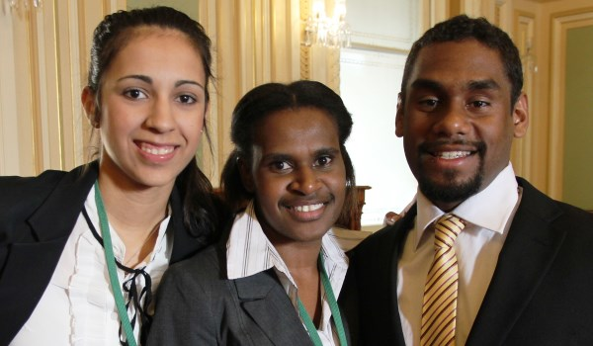
For more information and to apply visit:
https://www.qld.gov.au/atsi/education-training/indigenous-youth-leadership-program
Or telephone: 3006 8866
Application to be received by Wednesday 30 April 2014

