*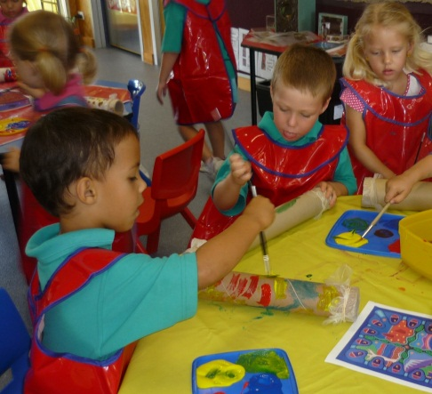*NA02125_NA02125_* Murri Kids *

*FREE*

 Playgroup

Come and play the Murri way



Are you interested in attending an

Aboriginal and Torres Strait Islander Playgroup?

Yes / No



Please indicate the number of children who would be attending playgroup with you?



Please provide contact details so we can contact you when Playgroup is ready to start.

Name:

Address:

Phone:

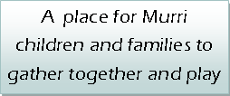

Please email to [bernadette\_scott@rok.catholic.edu.au](mailto:bernadette_scott@rok.catholic.edu.au) or

Fax: 49313731 or drop it into the

Catholic Education Office

143 West Rockhampton Q 4700