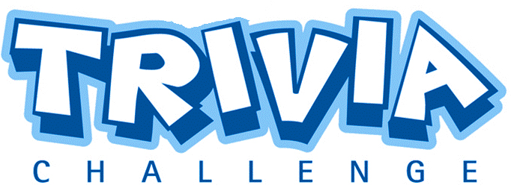
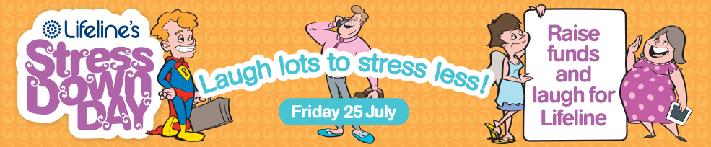
Stress Down Day is a fun and easy initiative to reduce stress and raise awareness for Lifeline.
Get involved on July 25 and have fun by helping us raise funds through the power of laughter.
Did you know that 98% of Australian’s agree that laughter has a large impact in reducing stress!
That’s why this year’s theme focuses on laughter!
We are encouraging you to laugh more to stress less and help raise funds for Lifeline.

Trivia Night Team Entry Form

Team Name:

Team Contact Phone:

Team Contact email:

No. of Team Members: (6-8)

Any special requirements:

Team Admission : $15.00 per head including finger food and OJ/ water/ Tea/ Coffee

Total Admission Due: $ (Payment must be received within 14 days of booking your team at 229 Musgrave street, North Rockhampton during Business Hours (Across the Road from Nthside Plaza…Across the driveway next to the Army disposals. Cash payment ONLY) (6 team members = $90.00, 7 team members = $105.00, 8 team members = $120.00)

Email completed forms to sam.barkworth@uccommunity.org.au OR Fax to 49307373 OR Phone your details through on 49307300.

Office Use: Payment received. Team Details Entered

Please return this form along with your payment to our office at 229 Musgrave st,
North Rockhampton (across the road from North side Plaza)
Between 10am and 2pm Monday – Friday
DETAILS AND PAYMENT NEED TO BE RECEIVED BY FRIDAY THE 27th OF JUNE !

