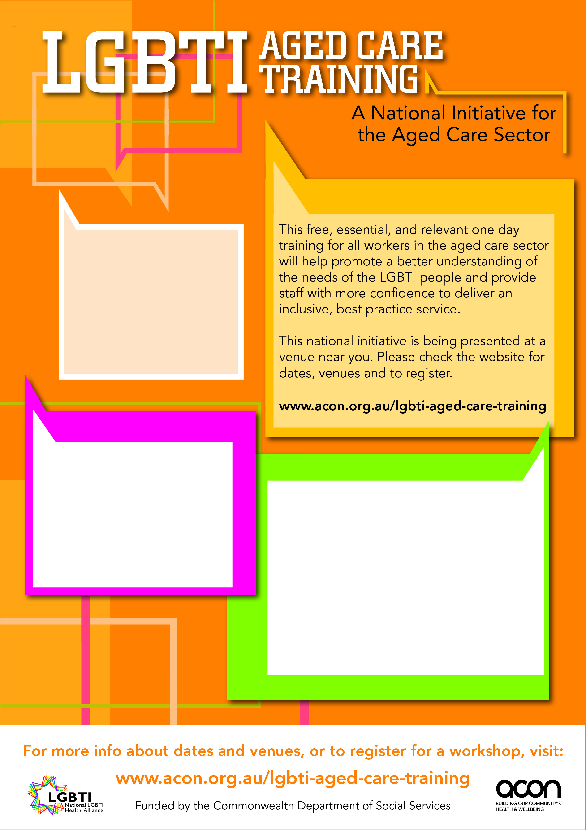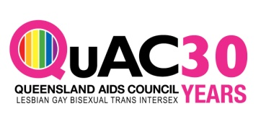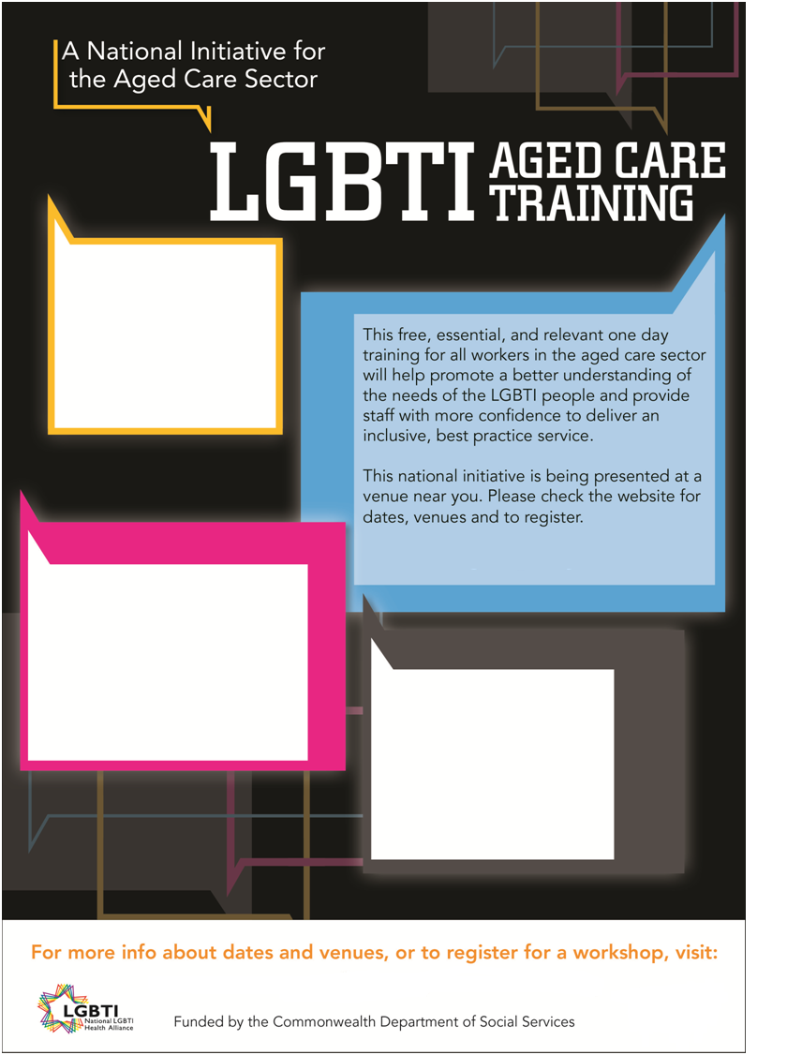

**2015**

6 Feb – Palmwoods SC

10 Feb – Southport

TBA Feb - Hervey Bay

10 March – Springfield Lakes

17 March – Mackay

19 March – Townsville

21 April – Caboolture

TBA April – Rocklea

TBA April – Redlands

**www.quac.org.au/lgbti-aged-care-training**

**www.quac.org.au/lgbti-aged-care-training**

**2014**

~~22 July – Kirra GC~~ **CANCELLED**

31 July – Teneriffe

6 Aug – Chermside

19 Aug – Sandgate

26 Aug – Cairns

28 Aug – Townsville

2 Sept – Coolum SC

11 Sept – Sinnamon Park

17 Sept – Upper Coomera

24 Sept – Roma

2 Oct - Sunnybank Hills

8 Oct – Toowoomba

13 Nov – Coolangatta

25 Nov – Bundaberg

27 Nov – Rockhampton

9 Dec –Mansfield

TBA Dec – Enoggera

Registrations due 2 weeks prior and venue details sent out 1 week prior to each workshop.