Addiction and
Group Therapy Training
2oth, 21st and 22nd October, 2014

Presenter is Douglas Taylor
Manager of Salvos Counselling
In Brisbane

COST IS
$400.00 for the 3 days.

Held at
The Salvation Army
131 Park Street
North Rockhampton, 4701
Ph: 07 4923 5600

Contact Jenny
07 4923 5600

Workshop Times

9.00am – 10.30am
Morning Tea 10.30am – 11.00am
11.00am-12.30pm
Lunch 12.30pm – 1.00pm
1.00pm – 2.30pm
Afternoon Tea 2.30pm – 2.45pm
2.45pm – 4.15pm
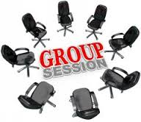
Training Schedule

GROUP THERAPY – Day 1
Introduction:
- History
- Background and overview
- Aims and objectives
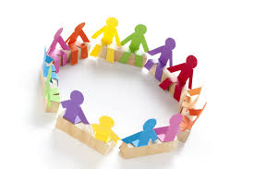
Looking at Groups:
- Leadership
- What to look for in groups and Why?
- Group Process
- Group Dynamics

Leading Groups:
A, Planning
B Evaluation
C. Intervening
Closure

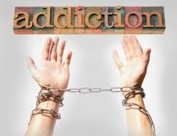ADDICTIONS – Day 2 and 3:

- Patterns of Compulsive Behaviors
- Addiction Theories
- Addiction Range (Substance versus Process)
- Origins Of Drugs
- Psychoactive Drugs and their effects
- When Use become Abuse
- Interventions.
  - 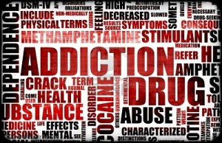Detox
  - Counseling
  - Pharmacological
  - Family
  - Supports

