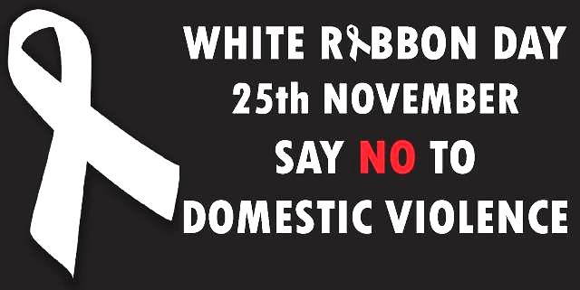

When: | Tuesday 25th November 12:00noon - 2:00pm
Where: | Morgan Street
Contact: | Relationship Australia Queensland  Community Hub
Street BBQ Free of Charge
Please wear your Heels to show your support
Relationships Australia Qld Mt Morgan; Mount Morgan Queensland Police Services; Bidgerdii AMS Mount Morgan and the Mt Morgan Community invite all to come along to our White Ribbon free of charge Street BBQ.
For More Information Please Visit:
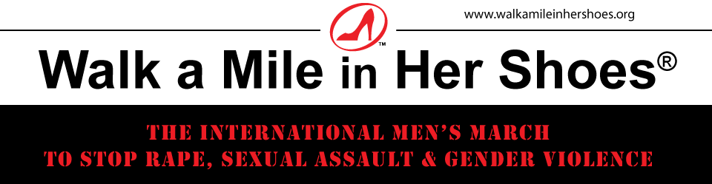
www.whiteribbon.org.au

