NDIS Quality and Safeguarding invitation to public meetings - Brisbane and Townsville
Registration closes on 27 March 2015 for the Brisbane meeting, and 30 March for the Townsville meeting.

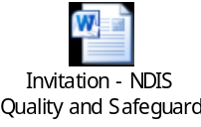

Communication and Parenting Seminars in Emerald
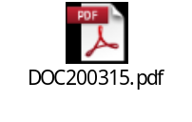

Assisting with Supporting Care Needs
KickStartCQ e-bulletin - 18 March 2015

