The Community Centre
Would like to invite you to a FREE
Afternoon tea
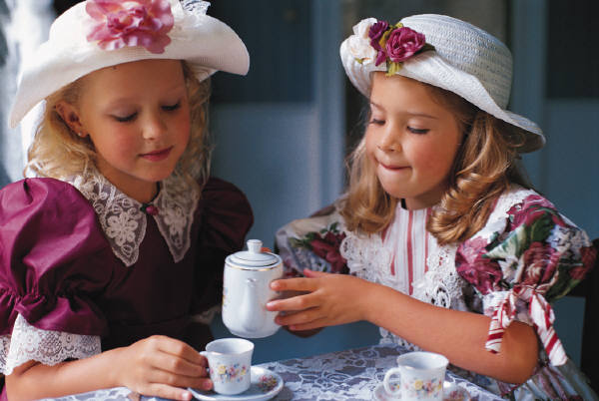

When: Friday 6 March 2015
Time: 2pm
Where: Community Centre, Rooms A & B,
80 John Street, Yeppoon.

