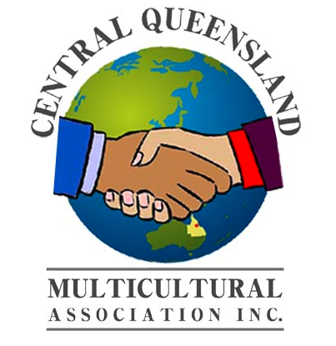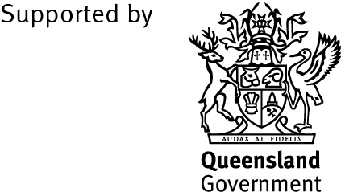

NEWS RELEASE
Central Queensland Multicultural Association (CQMA)
The 6th Year of The Taste of the World Festival

Saturday 23rd May 2015
Time: 1100hours (11 am) – 1630hours (4.30pm)
Venue: Rockhampton Show Grounds.
Entry: $2 per adult
Children: under 15years of age free

The ‘Taste of the World Festival’ is a unique, annual multicultural event celebrating the rich cultural diversity of the Central Queensland Region. The festival features include fantastic culinary delights from around the world; a brilliant diversity of world music and dance, featuring a wider range of traditional costumes.

This one-day festival has three major components:

Taste of the World – an exciting mix of community and commercial food stalls. Multicultural communities are able to share the unique tastes of their homeland with the broader community and celebrate their heritage, and local businesses have the opportunity to showcase their produce and promote dining destinations within the Central Queensland Region.

Cultural Entertainment – an entertainment program that incorporates a number of unique cultural performances from local individuals and community groups. We invite children groups to show their talents not only in traditional song, dance or instrument playing but to stage their own ‘pop’ entertainment segments.

Showcase Cultural Diversity at its best – an opportunity to showcase the cultures of Central Queensland culturally and linguistically diverse communities to celebrate the skills of the community members through cooking demonstrations, displays, crafts and cultural activities.

There will be Cooking Competitions in the categories of Master Chef, Multicultural Group Cuisine, and Children/Adult Teams. Participants just need to love cooking and having fun to be part of the following competitions. Participants do not need to be qualified chefs just love cooking.

The “Master Chef” Cooking Competition is an opportunity for any up and coming or experienced local cooks or aspiring chefs in the region to exhibit and promote their skills and knowledge. In the “Multicultural Group Cuisine” this is a chance for the community to experience the Tastes of the World that will be cooked and served up by the diverse cultural groups. Children teams (one adult per team of four) are encouraged to be part of the Children Competition. At the end of each cooking segments, a selected panel of judges will judge each dish and prizes will be awarded.

These competitions are not to be missed as your cooking talents and participation will be acknowledged at our festival.

Plus much, much more fun entertainment …………

Free - Petting Zoo, Merry Go Rounds and Jumping Castle for Children.

Food, Education & Information, Arts and Crafts, Trash and Treasure Stalls

Stall sites - registrations are now open: contact Mobile: 0438751974 or
Email: cqma_inc@hotmail.com
Stall Holders who wish to cash in on the ‘Early Bird’ Stall Site Registration fee - need to register before the 1st May 2015.

