LIFE isn’t about finding yourself, LIFE is about creating yourself.

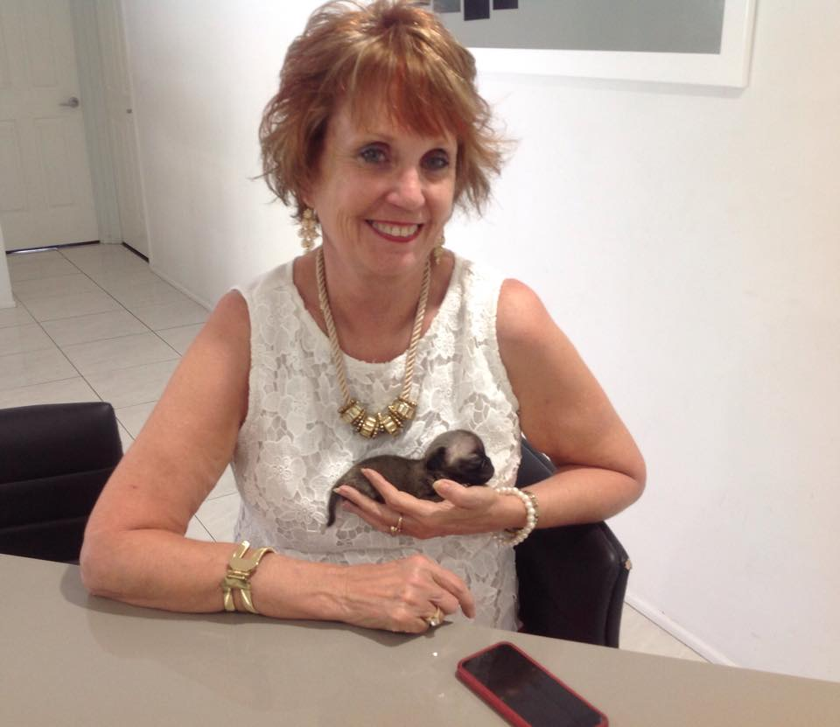  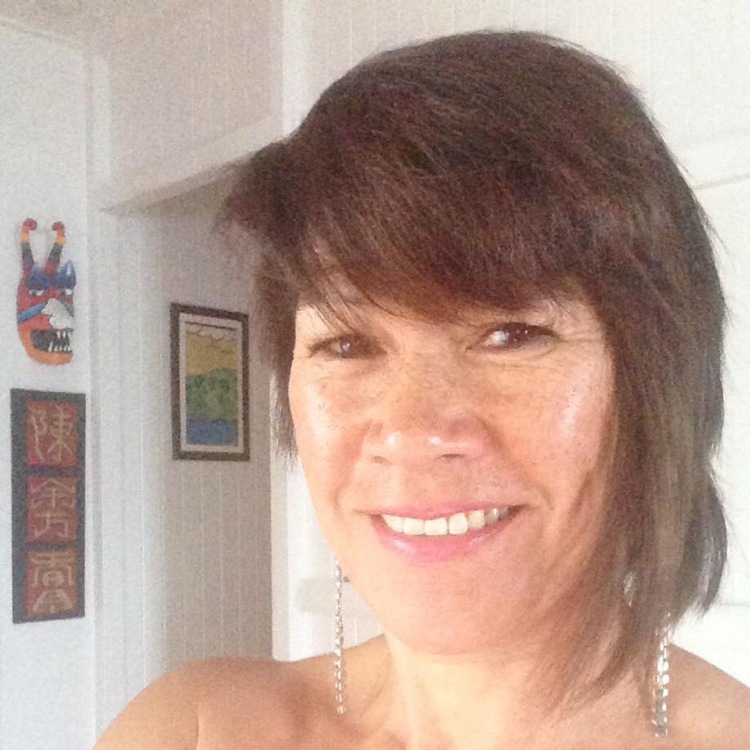 |  |  | “Denise”  My life was turned upside down when the love of my life, passed away suddenly at 55. I found myself at a crossroads in my very planned life and had some choices to make, I could die slowly or choose to step courageously into my new life. I choose to step into my new life.  “Ros”  “After many years of giving and supporting others through their grief and loss, at 45yrs of age Ros found her world was turned upside down overnight with the death of her husband 10 years earlier. Ros’s shares how her faith helped her get through the darkest period of her life that changed her status from Married to Widow.  “Maudie”  “I come from a culturally traditional large extended family where supporting loved ones through their grief and loss was all part of the package. However, I have recently been through my own personal loss which cut through to the core of my being. I could have lay down and wallowed in my grief but I haven’t I decided to live.
REBOOT LIFE PTY LTD
Rockhampton, Queensland 4700
TEL: | inquiries@grief.com | Livingwithgrief.com.au
June 17, 2015 9:00am to 3:00pm

