

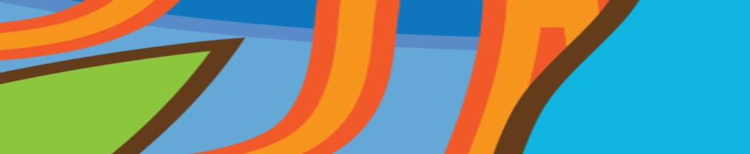



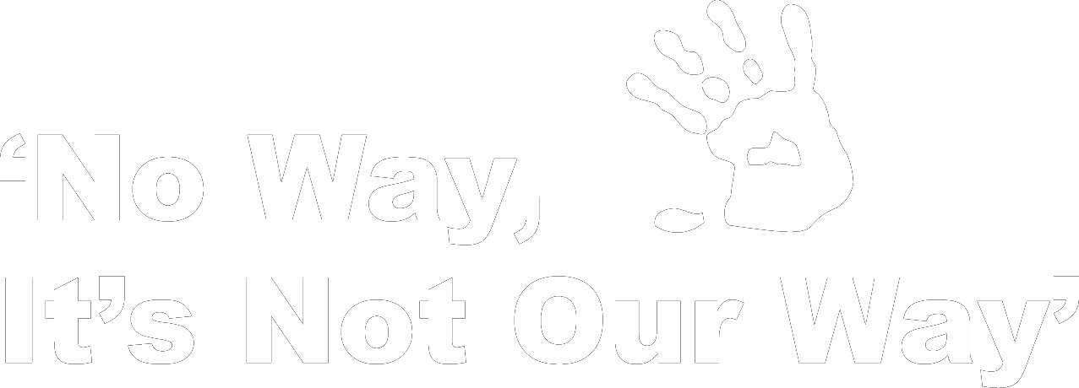

**QIFVLS**



**Queensland Indigenous Family Violence Legal Service**

Signs of Healthy and Unhealthy Relationships

Cap Coast Community Legal Education

Livingstone Shire Council

Date: 12th May, 2015

Venue: Community Centre, 80 John St, Yeppoon

Time: 10:00am – 12:00pm

Morning Tea supplied