





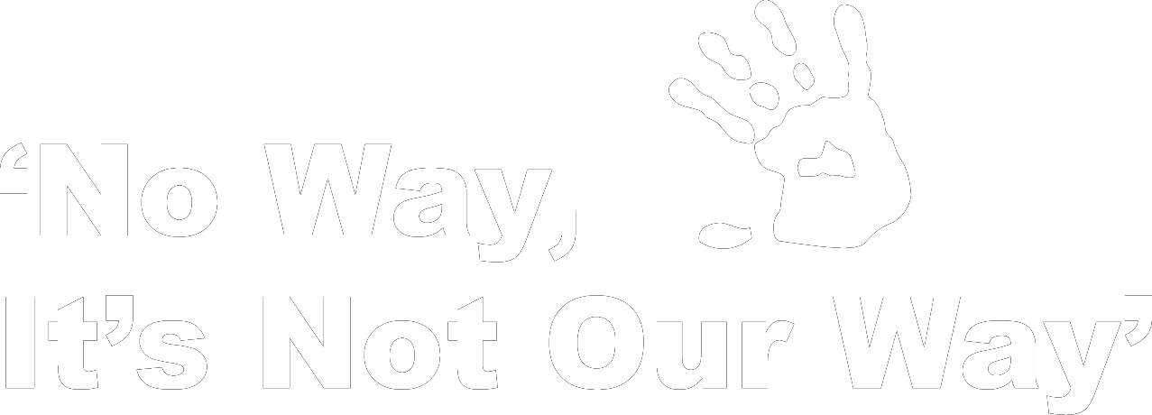

**QIFVLS**



**Queensland Indigenous Family Violence Legal Service**

Signs of Healthy and Unhealthy Relationships

Cap Coast Community Legal Education

Livingstone Shire Council

Date: 27th May, 2015

Venue: Community Centre, 80 John St, Yeppoon

Time: 2.30pm – 4.00pm

Afternoon Tea supplied