Harmony day: Capricorn Coast
Celebrating cultural diversity in our community and promoting inclusiveness, respect and belonging.

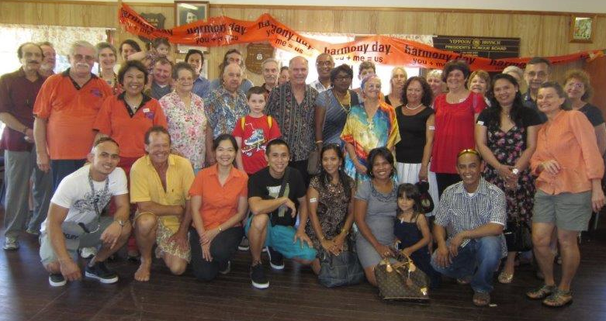  You’re welcome to join us.  The CCHWG are forming a working committee to look at adding and expanding on our initial ideas and creating an event schedule. Everyone can have a part: we need planners, networkers, doers, speakers and big picture thinkers. We are friendly and supportive, and feel:  As a team, we can create great things together!  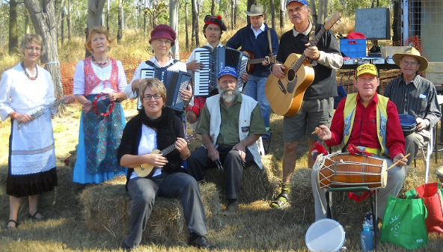 |  | Planning is underway  The Capricorn Coast Harmony Working Group (CCHWG) had their first planning meeting on the 27th May 2015 to discuss the way forward for the March 2016 Harmony Day event, and have brainstormed some initial ideas as to activities for next year.  Thanks to the generous financial support from CentreCare, and the in-kind support offered by the Livingstone Shire Council, the CCHWG is positioned well to implement an exciting program in 2016! We are all busy, so planning is essential, and we need to start now.  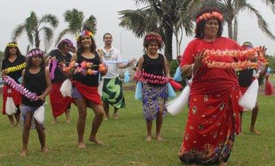
contacts:
Joy Davison-Lee Helen Gallehawk Suraj Shrestha
joydavisonlee@gmail.com hgallehawk@outlook.com suraj.shrestha@livingstone.qld.gov.au
04 2323 4842 04 0474 7940 07 4913 3823

Photos are from previous Harmony Day events: Great people, great time, great day!
our initial brainstorming Ideas: School projects (singing, signing, cooking, dancing); Games from other cultures; Stories; Tree plantings; Banners/umbrellas; Speakers on a pre-defined harmony theme (community leaders including spiritual leaders, refugees, students); and monthly CCHWG morning teas.

Morning tea: Please feel free to come along to Garage CDC 80 John Street Yeppoon on Tuesday 9th June at 1pm, and share your thoughts over a cuppa. Our first priority for the month of June, is to identify a working committee and ideas for events, then we can assess what ideas are achievable with the resources we have.

