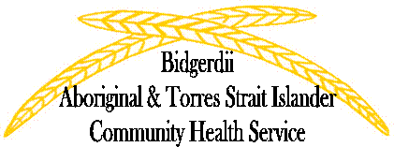

On behalf of the Partners in Recovery Program and the Social and Emotional Wellbeing Team
Bidgerdii invites you to join us on
Thursday 8 October at 10am for a community morning tea
At 162 Bolsover Street
There will be information about mental health, giveaways and of course a delicious morning tea.

On behalf of the Partners in Recovery Program and the Social and Emotional Wellbeing Team
Bidgerdii invites you to join us on
Thursday 8 October at 10am for a community morning tea
At 162 Bolsover Street
There will be information about mental health, giveaways and of course a delicious morning tea.

