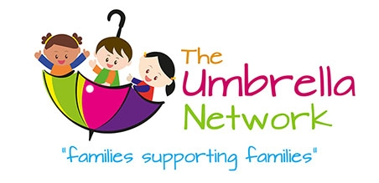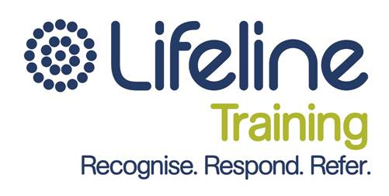

**Date:**

Monday 25th Jan 2016

**Time:** 9am-4pm

*Please note there is a limit of 3 participants per organisation

Lifeline is a national organisation that has been providing a range of crisis support and suicide prevention services in Australia for over 50 years.

There are some significant benefits of engaging Lifeline corporate training, all profits raised from training in Queensland go back into our Crisis Support Service where revenue has a direct impact in meeting call demand and ultimately saves lives.

**Cost:** Normally $278this training will be funded and delivered at the

**special price of $20pp**

**Address:** UnitingCare Community Training Room, 229 Musgrave St, North Rockhampton

**How to register:** phone 4928 6550 or

email [info@umbrellanetwork.org](mailto:info@umbrellanetwork.org)



**1 day Training**

**Morning Session**

**Accidental Counsellor**

Accidental Counsellor is an emotional crisis awareness training program:

**Topics covered**

* What is a crisis?
* Mental health problems
* Substance use
* Loss and grief
* Trauma
* Relationship issues
* Stress (including workplace stress)
* Appropriate resources

This program includes a 2 hour E-learning module that must be completed prior.

**Afternoon Session**

**Handling Challenging Callers & Behaviours**

Participants learn skills to respond appropriately to people who are distressed, upset or aggressive:

**Topics covered**

* Workers’ experiences
* The distressed client
* Vantage points within a difficult situation
* Communication skills
* Roadblocks to communication
* Problem solving skills
* Role clarification to help set boundaries
* Risk assessment