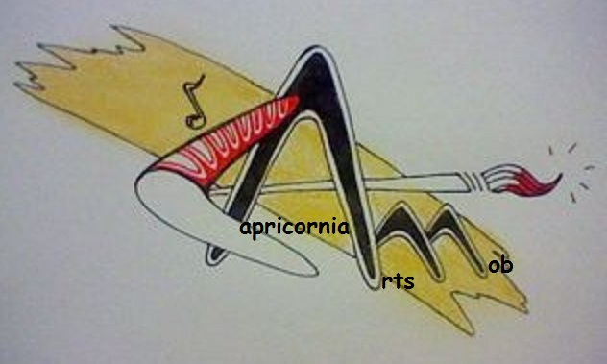
CAPRICORNIA ARTS MOB

INVITES everyone to a NAIDOC 2016 event

Exhibition and Film launch featuring Community members

‘Creating Songlines on Dharumbal Country’

at CAM Studio at Walter Reid Cultural Centre
Corner East Street and Derby Street Rockhampton City

Gallery Times

July 11 through to July 17
Monday to Friday - 10am to 4pm; Saturday and Sunday - 10am to 4pm

Official Opening
Friday 15 July between 3 - 5pm

Contacts Curator - Laurel Mason 0429405624

Many thanks to our partner organisation Gumbi Gumbi
And ‘in kind’ and funding supporters’
