Depot Hill Car Rally and Family Fun Day
Food for Sale
Rides and Stalls
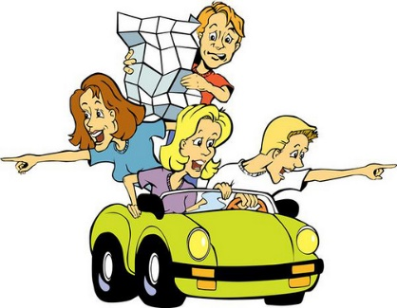
Iron Man competition
When: Saturday, 10th Sept. 9am- 3pm
Be at the school by 8.30am for registration
What: Dress yourselves and your car up to a theme and then drive along a set course to answer questions and win prizes
Where: Start at Depot Hill State School- Meet near the oval
Cost: $20 per car
Why: To win cash$$$ and prizes and support the children at Depot Hill State School
Loads of prizes to be won
Best dressed car, man, woman and child
1st Prize: $200
2nd Prize: $100
3rd Prize: $50
Winners announced at 1pm

Enquiries: 49221795

