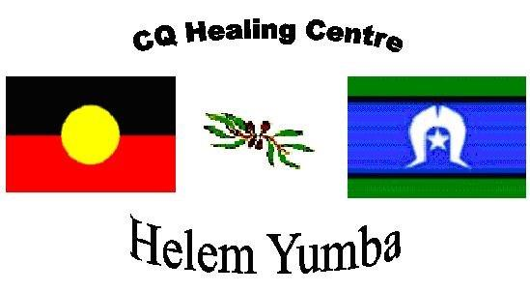 Cultural Competency Training

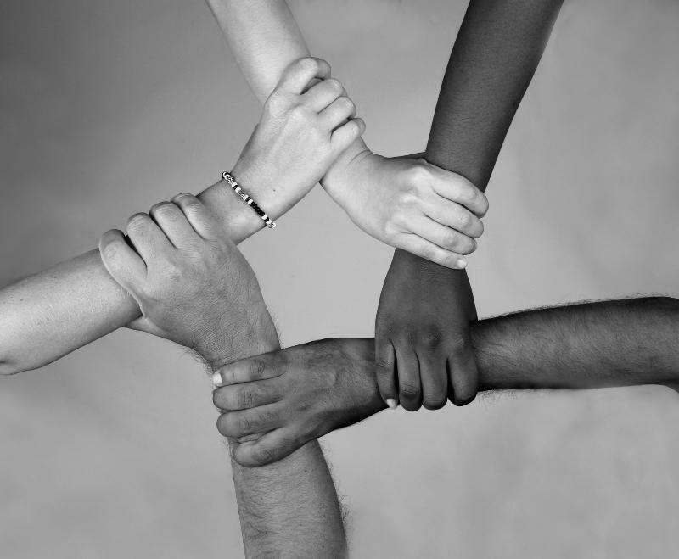

Increase service providers' capacity to engage in Aboriginal and Torres Strait Islander communities

Helem Yumba, the CQ Healing Centre, is now offering Cultural Competency Training. Helem Yumba has developed this training to support non-Indigenous service providers to engage and work with Aboriginal and Torres Strait Islander families, individuals, young people and children.

**If this sounds like something you would like to learn more about, please contact Helem Yumba on 1800 776 727 or email** [**admin@cqhealing.com.au**](mailto:admin@cqhealing.com.au) **to register your interest.**

Assist in the development of Aboriginal and Torres Strait Islander communities within mainstream services

Improve the awareness of Aboriginal and Torres Strait Islander Cultures

Acknowledge everyone’s culture and beliefs