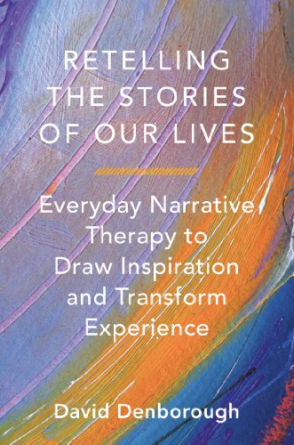

**Using a narrative practice approach with a structure guided by David Denborough’s (2014) Retelling the stories of our lives: Everyday narrative therapy to draw inspiration and transform experience.**

Date: Friday, 2nd of September

Time: 9:30 am – 11:30 am

Venue: headspace Rockhampton

Cost: Free ☺

Starting 2nd of September 2016 at headspace Rockhampton.

**This group is for young people with an interest in writing who would like to respond to concerns about identity or social and emotional wellbeing.**

***Writing Our Stories in Ways that make us Stronger***