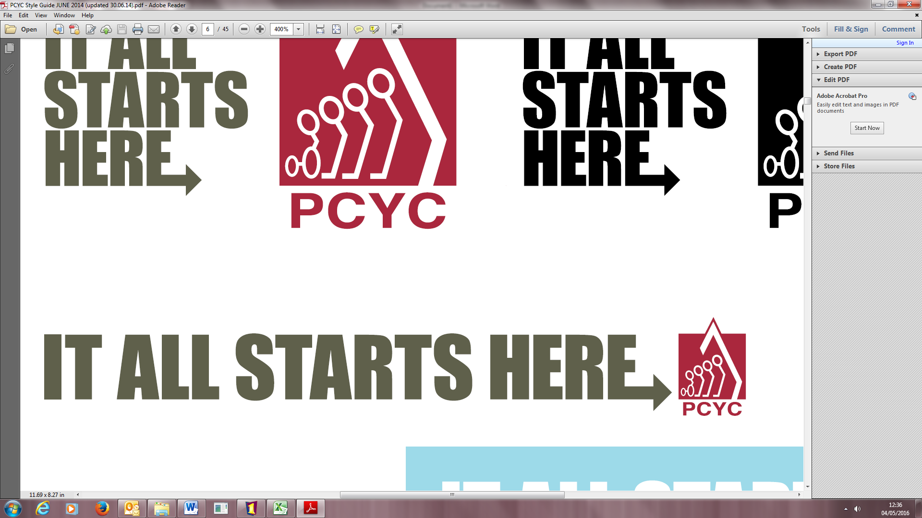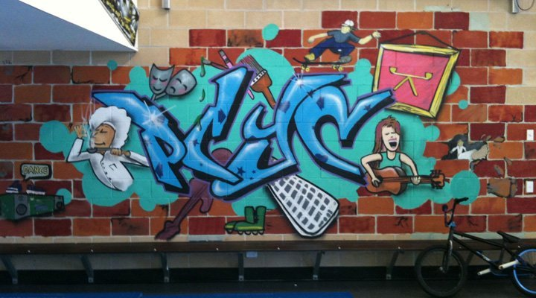YOUTH SUPPORT SERVICES

Monday - Friday, 8.30am - 5.00pm

SUPPORTING YOUTH TO:

* CONNECT positively
* ENGAGE in school/employment
* LIVE in a safe environment
* LEAD a healthy and violence free life

Feel like a chat or just to see where we are call or drop into Youth Support Services…



PCYC ROCKHAMPTON

Stapleton Park, Bridge Street, North Rockhampton QLD 4701

**P:** (07) 4927 7899 **E:** [rockhampton@pcyc.org.au](mailto:rockhampton@pcyc.org.au)



***Funded by Department of Communities, Child Safety and Disability Services***

***Funded by Department of Communities, Child Safety and Disability Services***