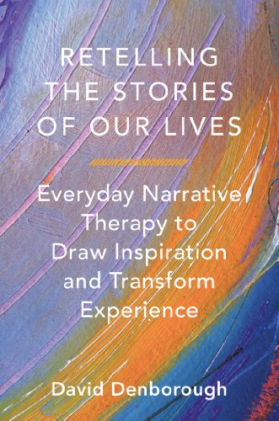

**Using a narrative practice approach with a structure guided by David Denborough’s (2014) Retelling the stories of our lives: Everyday narrative therapy to draw inspiration and transform experience.**

Dates: September – 2nd, 9th, 16th, 30th

October- 7th, 14th, 28th

November- 11th and 18th

Time: 9:30 am – 11:30 am

Venue: headspace Rockhampton 155 Alma St.

Cost: Free ☺

Limited spaces- to Register or for more information please contact headspace Rockhampton on

49219 800

***Writing Our Stories in Ways that make us Stronger***

**This group is for young people aged 17 – 25 yrs with an interest in writing who would like to respond to concerns about identity or social and emotional wellbeing.**