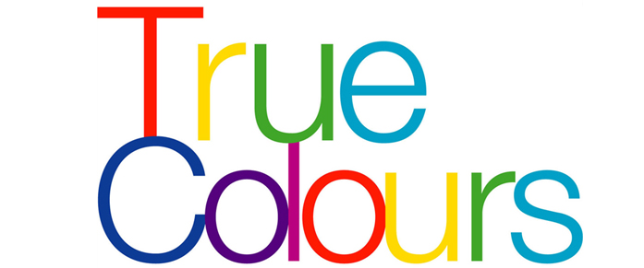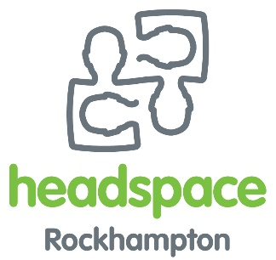

**We would like to welcome you to join the True Colours Support Group to listen to Guest Speaker Loretta George on Tuesday the 27th September of 2016**

**True Colours is a support group for young people aged 14-19 in the Rainbow community**

**The group catches up fortnightly on Tuesdays from 3-5pm at headspace Rockhampton**

**Light afternoon tea is provided**

**155b Alma Street Rockhampton 4700**

**(07) 4921 9800**